**Practical Drill – SQL**

1. Define the following UNIVERSITY schema in SQL

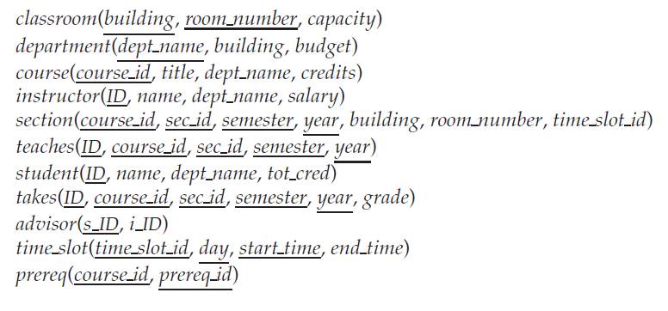

1. Insert minimum 4 entries in each table
2. Find the name and department of each instructor
3. Find the department names in the University
4. Display the ID, name, department name and salary of instructors after giving a 10% raise to each instructor
5. Retrieve the names of all instructors, along with their department names and department building name.
6. Retrieve the name and corresponding course id of instructors who have taught some course
7. Find instructor names and course identifiers for instructors in the Computer Science department
8. Find the names of all instructors whose salary is greater than at least one instructor in the Biology department.
9. Find the names of all departments whose building name includes the substring ‘Watson’.
10. List all instructors in Physics department alphabetically
11. Find the set of all courses taught in the Fall 2009 semester
12. Find the set of all courses taught either in Fall 2009 or in Spring 2010, or both
13. Find the set of all courses taught in the Fall 2009 as well as in Spring 2010
14. Find all courses taught in the Fall 2009 semester but not in the Spring 2010 semester

Create Table Classroom(

building varchar(3),

room_number int,

capacity int,

Primary Key (building,room_number)

);

Create Table Classroom(

building varchar(3),

room_number int,

capacity int,

Primary Key (building,room_number)

);

Create Table Course(

course_id varchar(20),

title varchar (10),

dept_name varchar(20),

credits int,

Primary Key (course_id)

);

Create Table Instructor(

instructor_id varchar(20),

instructor_name varchar (10),

dept_name varchar(20),

salary int,

Primary Key (instructor_id)

);

Create Table Instructor(

instructor_id varchar(20),

instructor_name varchar (10),

dept_name varchar(20),

salary int,

Primary Key (instructor_id)

);

Create Table Teaches (

instructor_id varchar(20),

course_id varchar(20),

section_id varchar (10),

semister int,

year int,

Primary Key (instructor_id,course_id,section_id,semister,year)

);

Create Table Teaches (

instructor_id varchar(20),

course_id varchar(20),

section_id varchar (10),

semister int,

year int,

Primary Key (instructor_id,course_id,section_id,semister,year)

);

Create Table Student (

student_id int,

student_name varchar(20),

dept_name varchar(20),

total_credits int,

Primary Key (student_id)

);

Create Table Student (

student_id int,

student_name varchar(20),

dept_name varchar(20),

total_credits int,

Primary Key (student_id)

);

Create Table Takes (

instructor_id varchar(20),

course_id

section_id

semister int,

year int,

grade varchar(5),

);

Create Table Advisors (

student_id int,

instructor_id varchar(20),

Primary Key( student_id,instructor_id )

);

Create Table Advisors (

student_id int,

instructor_id varchar(20),

Primary Key( student_id,instructor_id )

);

Create Table Pre_req (

pre_req_id varchar(20),

course_id varchar(20),

Primary Key (pre_req_id,course_id)

);